|  |  |  |  |  |  |
| --- | --- | --- | --- | --- | --- |
| Date | Dec 12, 2022 | | | Tester Name | Syed Shahabuddin |
| Environment | Penfax - Test | | | Login used |  |
| Operating System | Windows | Version: | Update: | | |
| Software Used | Edge | Version: | Update: | | |
| Select Software | Version: | Update: | | |
| Release version | 22.4.1 | | | | |
| Title | E26.05 | | | | |
| Test Type | Regression | | | | |
| Test Scenario | Receiving scheduled monthly payments with a withdrawal type of fixed amount, specified order depletion method and moving to the next PEPP step. | | | | |
|  |  | | | | |
| Expected Results | Confirming that ITA minimum amount for the year doesn’t change, and that the minimum age factor is correct when compared to VPB PEPP talk chart of minimum age factors, even after the birthdate change.  Confirm that the PEPP rollover doesn’t interfere with the scheduled payments & processes correctly. That the number of units do not change between the two funds.  The DAI changes as well as the interfund processes. Letter will generate for specified order. | | | | |
| Pass/Fail | Pass | | | JIRA# | N/A |

Find Active VPB member

SID: 248894

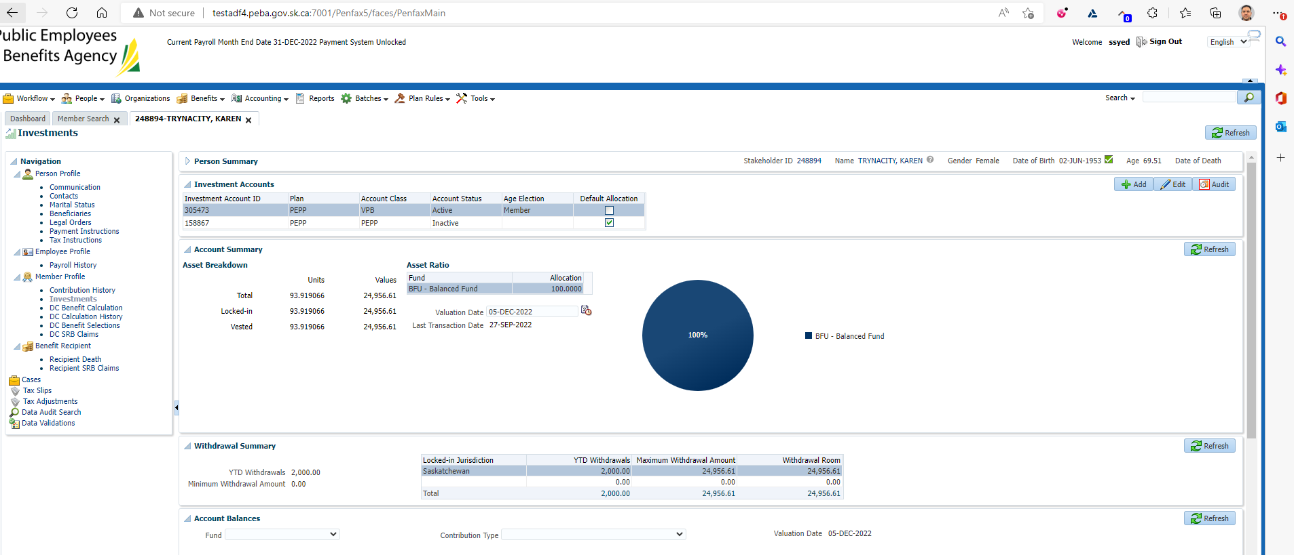

Processed interfund (to make 2 funds):

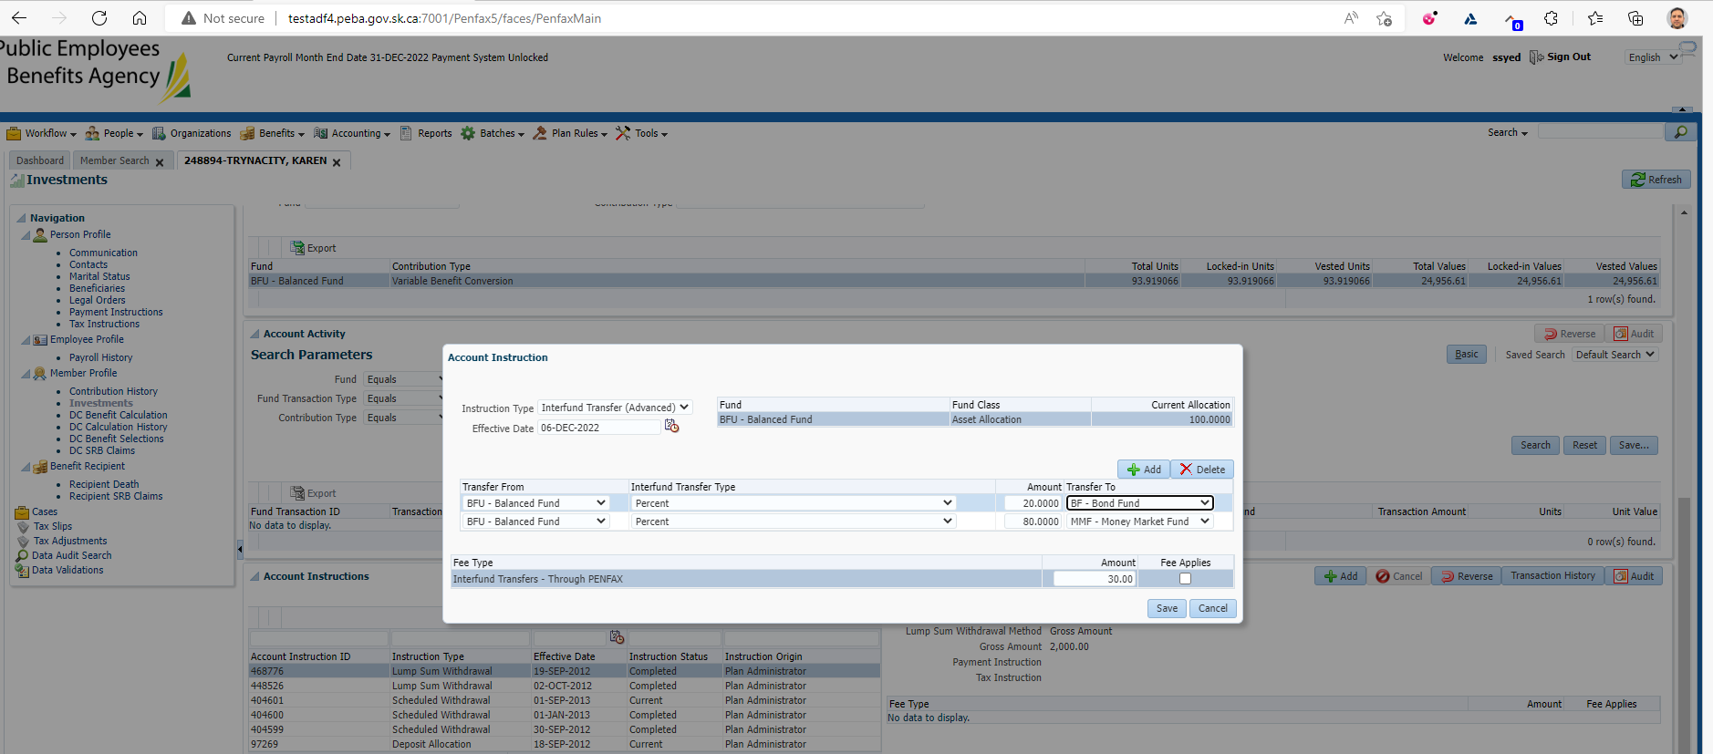

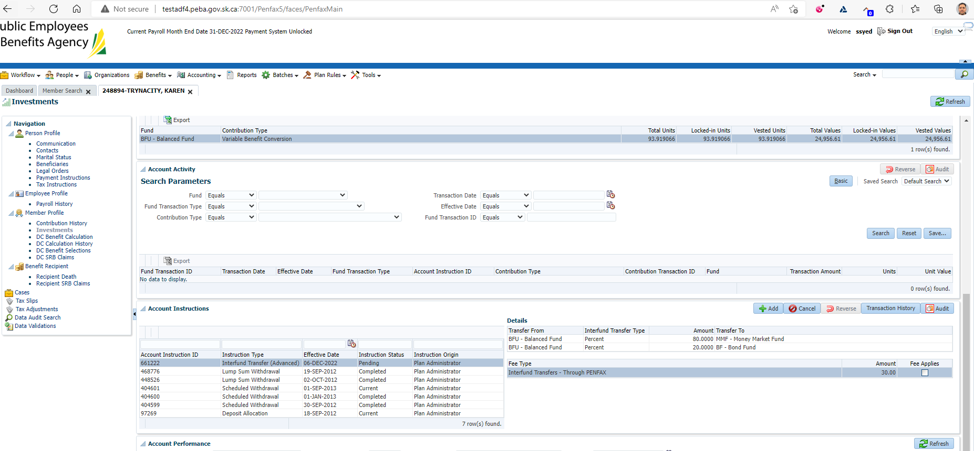

& updated birthdate to Dec 8th

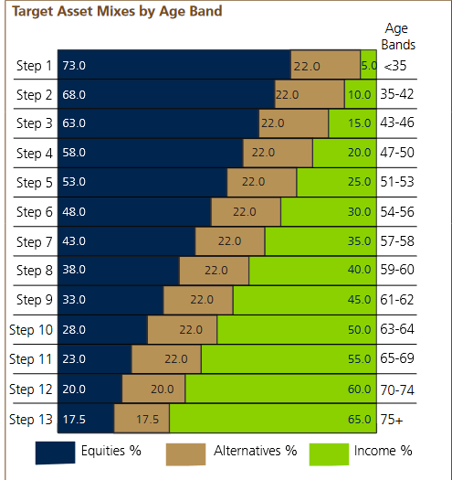

Added scheduled withdrawal, fixed, annual and specified:

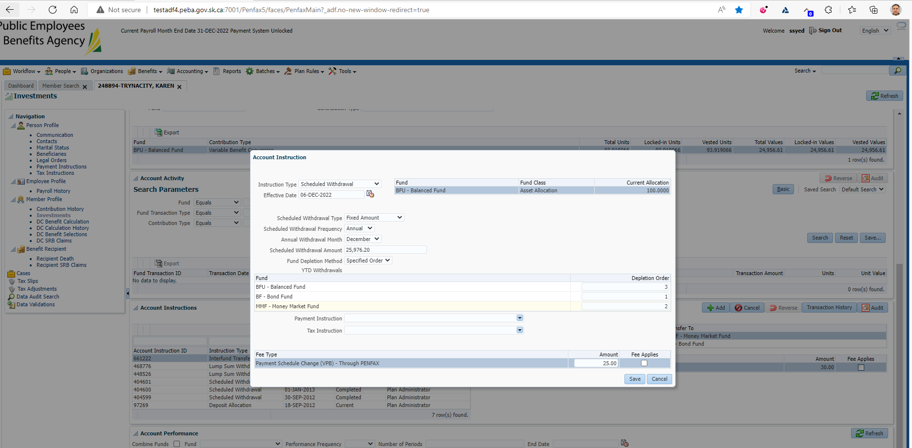

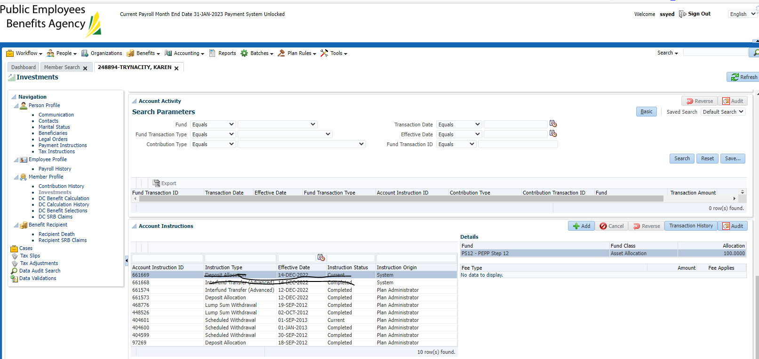

Waiting for DC Lifecycle PIT to run.

Initially test was scheduled for Dec 8th.

Test 2 got refreshed again on Dec 12th. Had to retest again and wait till Dec 15th for the results

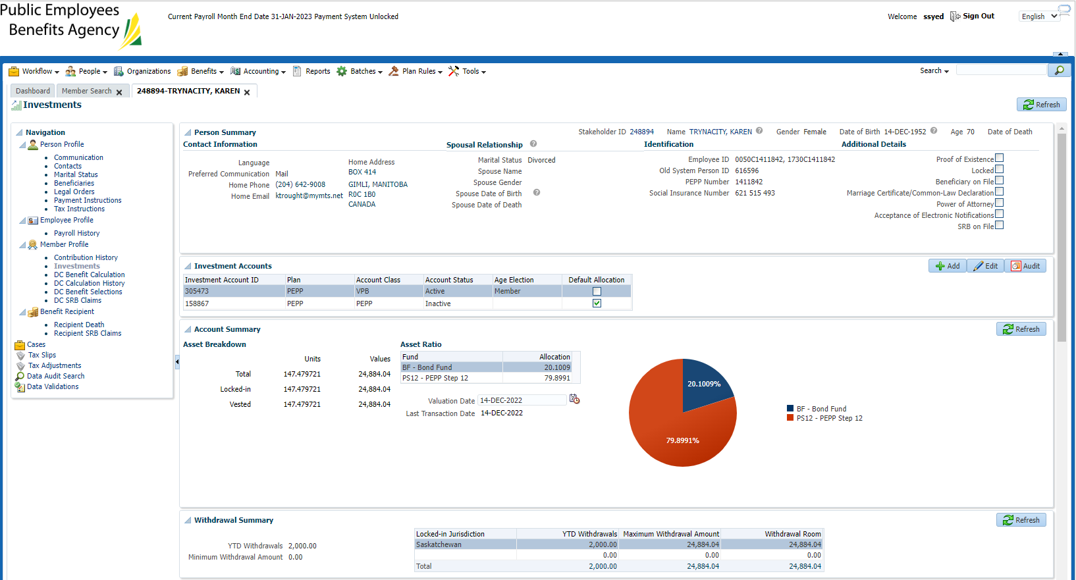

Next day, interfund completed:

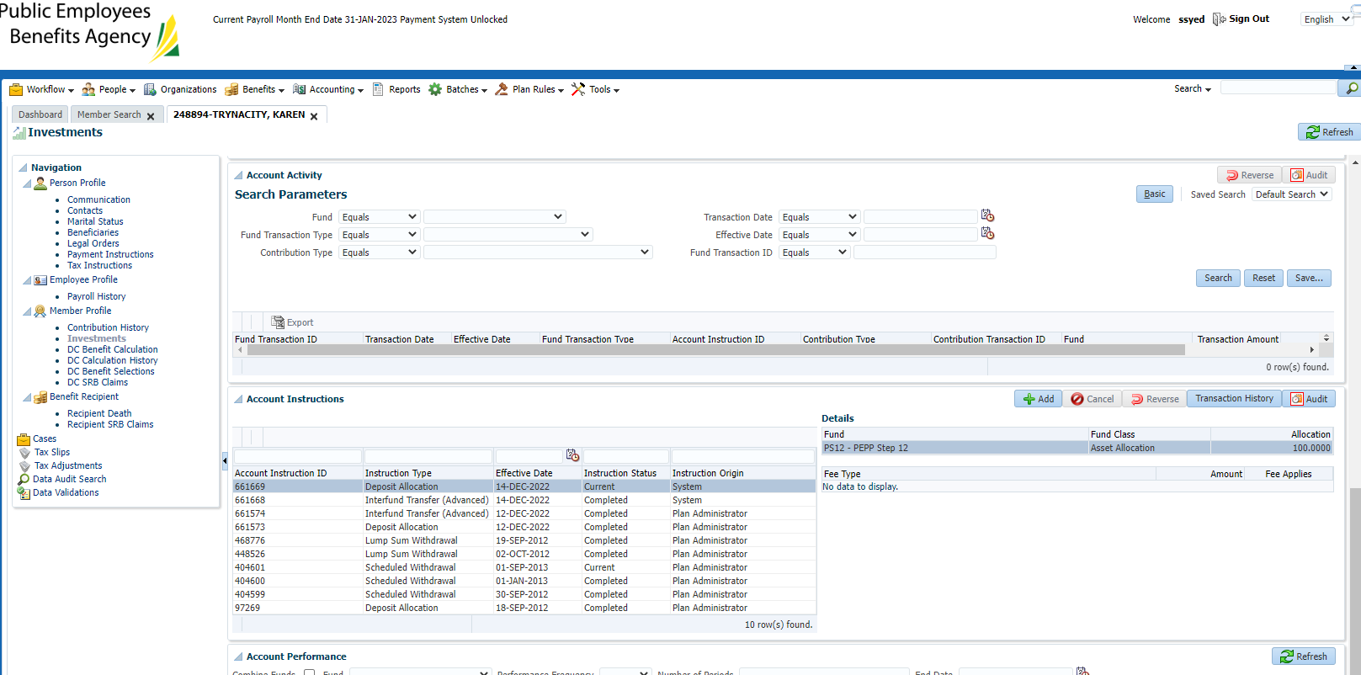

Letter generated, which is correct as it was a user completed interfund;

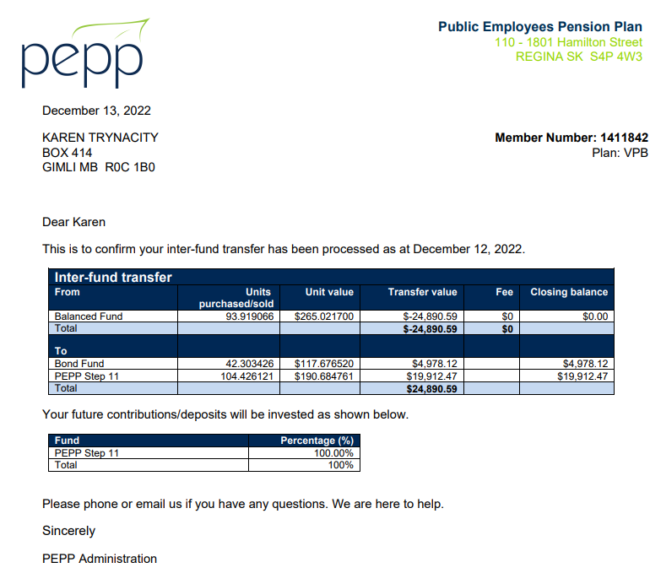

Day 3: Pending Lifecycle transactions & new scheduled withdrawal and DAI

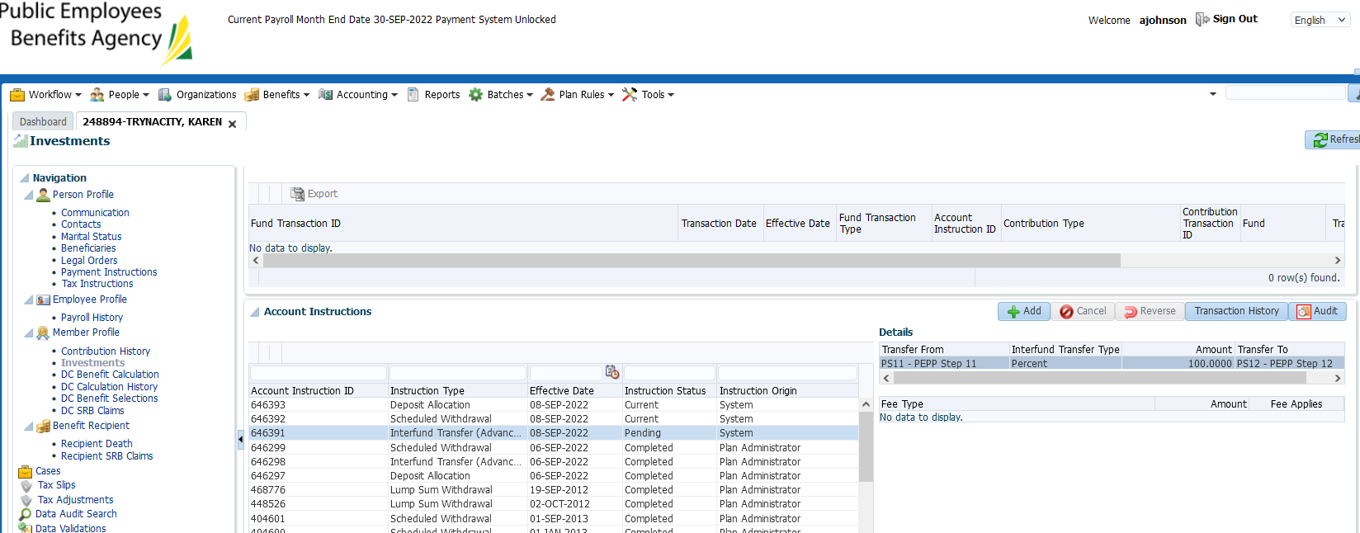

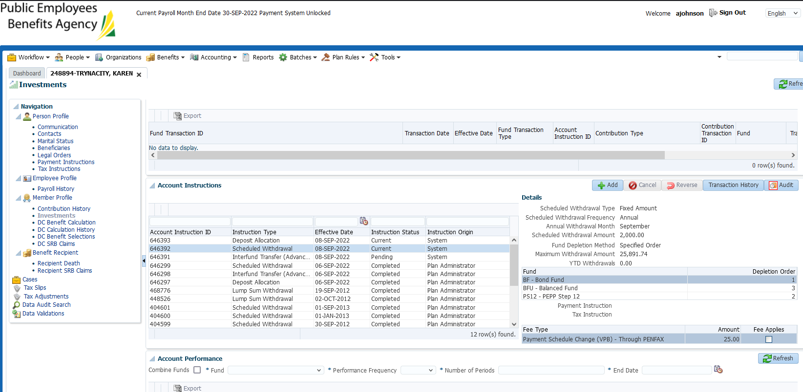

Letter generated for new scheduled withdrawal instruction (due to specified order), this is correct, does not get mailed to member but visible online:

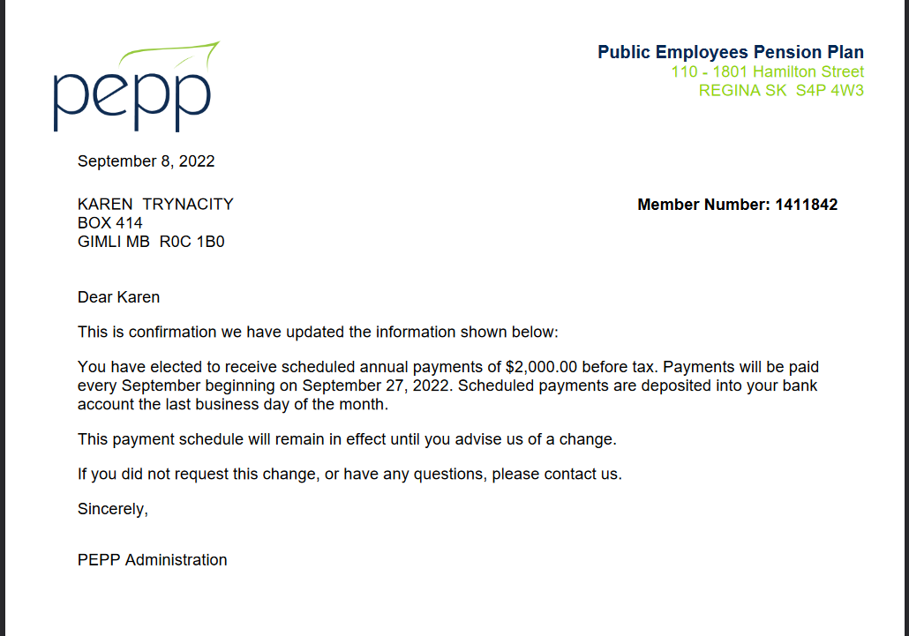

Day 4 – sept 9

confirm funds moved (re: pending interfund) & no letter generated for system interfund

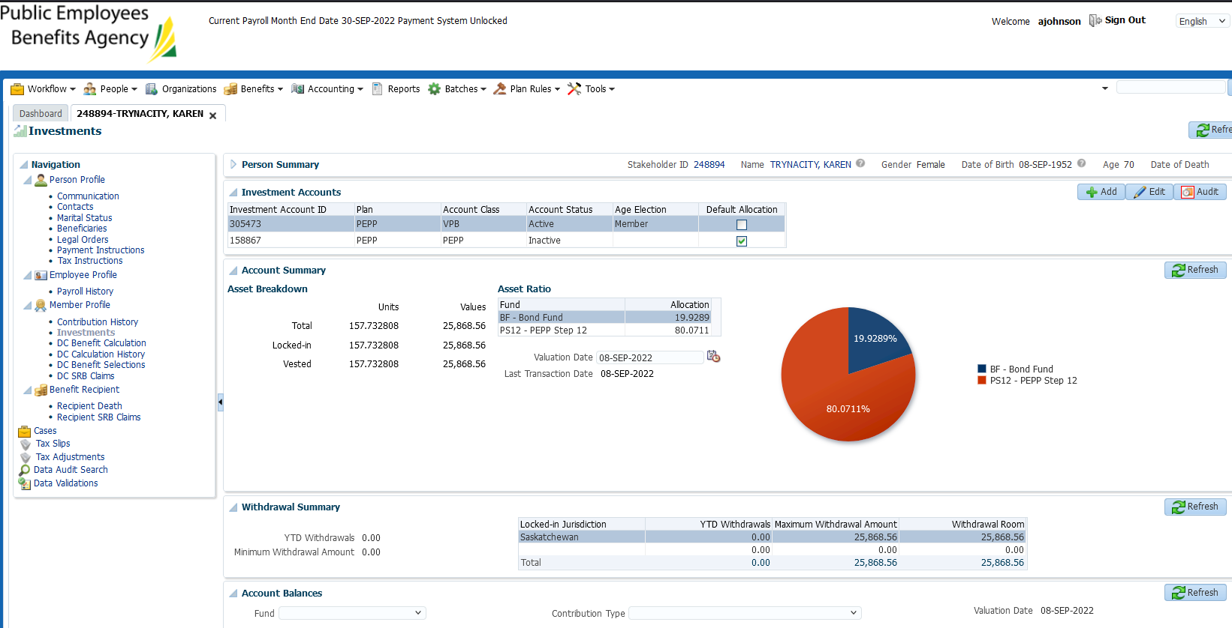

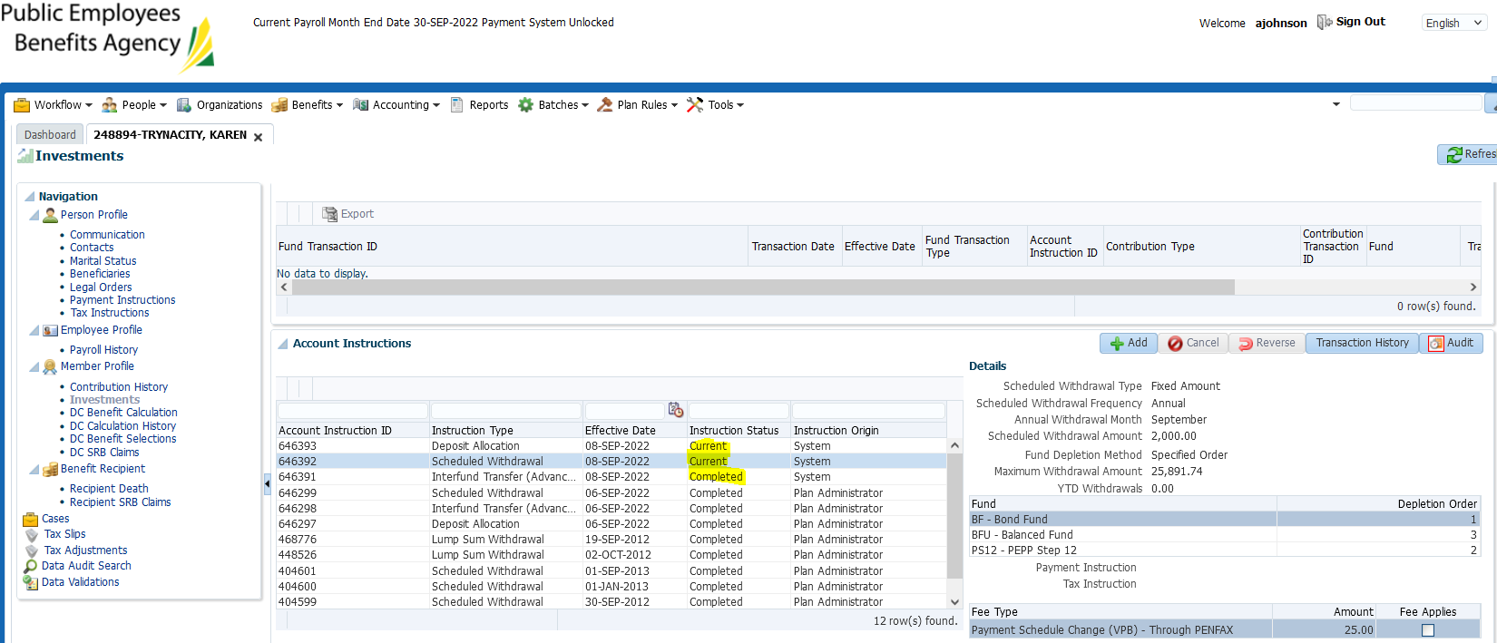

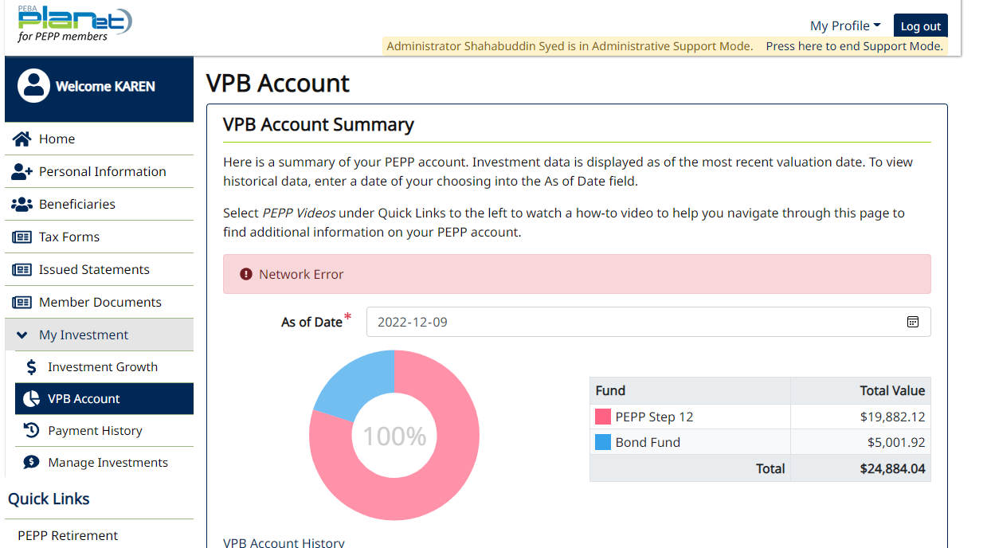

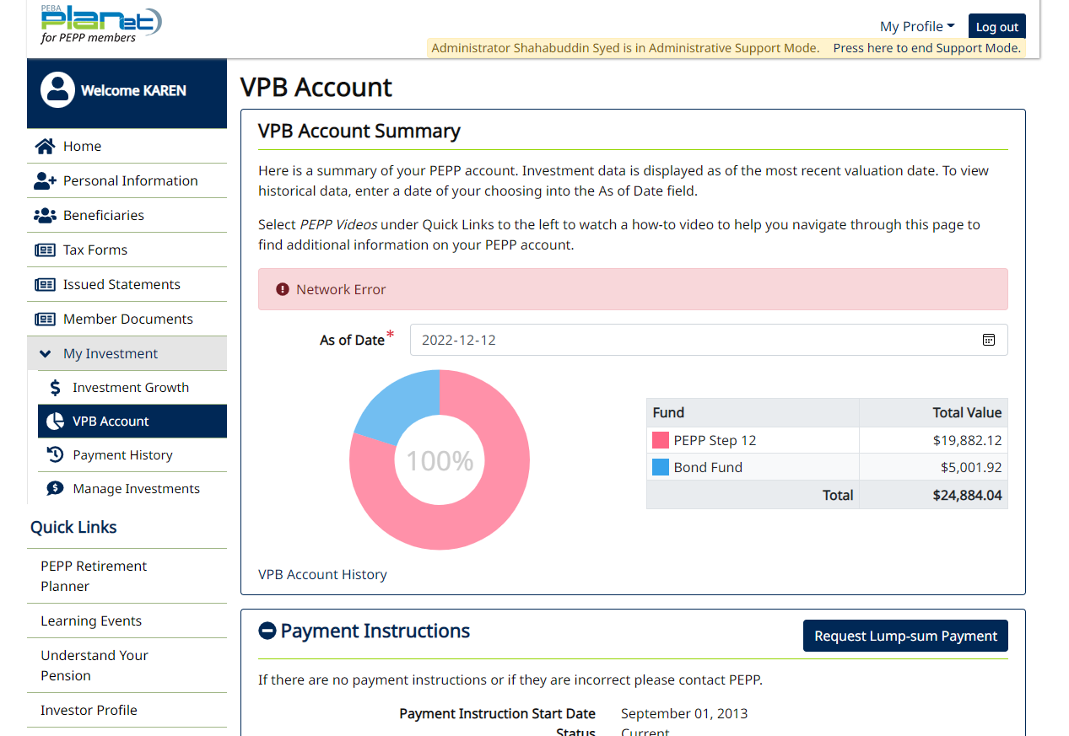

Letters ok – only change confirmation for specified fund order change generated. -passed

